**DAILY ONLINE ACTIVITIES SUMMARY**

|  |  |  |  |  |  |  |  |  |
| --- | --- | --- | --- | --- | --- | --- | --- | --- |
| **Date:** | **11 /6/2020** | | | | **Name:** | **Harshitha M** | | |
| **Sem & Sec** | **8th Sem** | | | | **USN:** | **4AL16CS038** | | |
| **Course** | **SMS** | | | | | | | |
| **Max Marks** | **60** | | **Score** | | | | | **60** |
| **Certification Course Summary** | | | | | | | | |
| **Course** | **Python for Machine Learning** | | | | | | | |
| **Certificate Provider** | | **Great Learning** | | **Duration** | | | **3 hrs** | |
| **Coding Challenges** | | | | | | | | |
| **Problem Statement:** **:** program to find the fibbonnacci series | | | | | | | | |
| **Status:Completed** | | | | | | | | |
| **Uploaded the report in Github** | | | | **yes** | | | | |
| **If yes Repository name** | | | | **Harshitha-M** | | | | |
| **Uploaded the report in slack** | | | | **yes** | | | | |

Online Test Details: (Attach the snapshot and briefly write the report for the same)

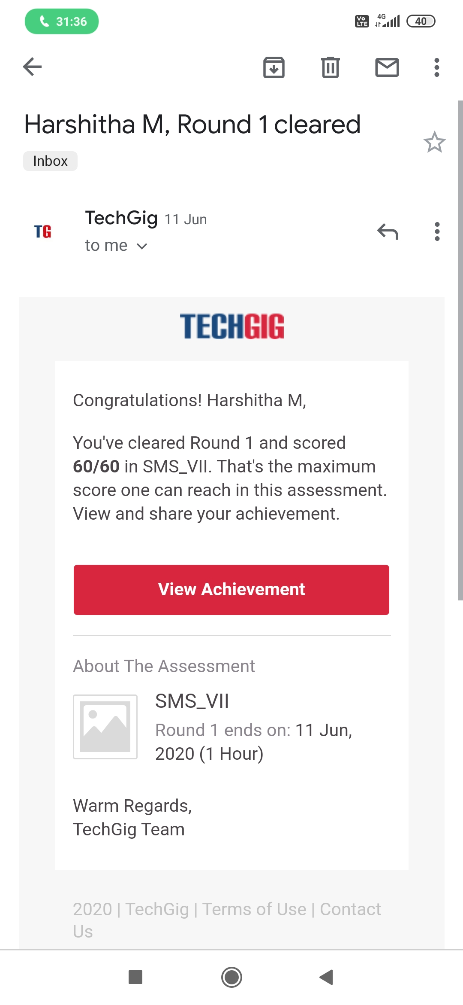

Certification Course Details: (Attach the snapshot and briefly write the report for the same)

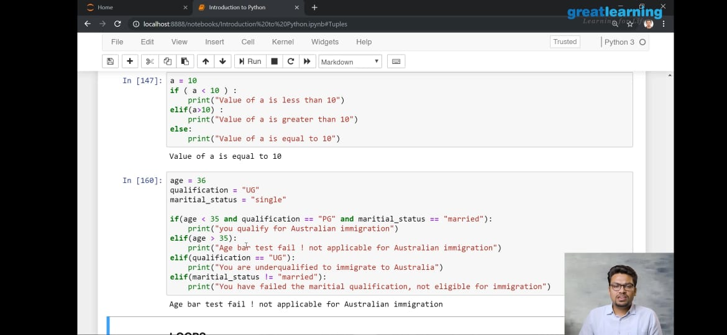

Coding Challenges Details: (Attach the snapshot and briefly write the report for the same)

PROGRAM1

def recur_fibo(n):

if n <= 1:

return n

else:

return(recur_fibo(n-1) + recur_fibo(n-2))

nterms = 10

if nterms <= 0:

print("Plese enter a positive integer")

else:

print("Fibonacci sequence:")

for i in range(nterms):

print(recur_fibo(i))